## Plan stages in action

Below is an example of how a plan stages setup might look.

Plan objects are set up on the base layer. These objects are always visible. Whilst daytime and nighttime stages contain different objects.

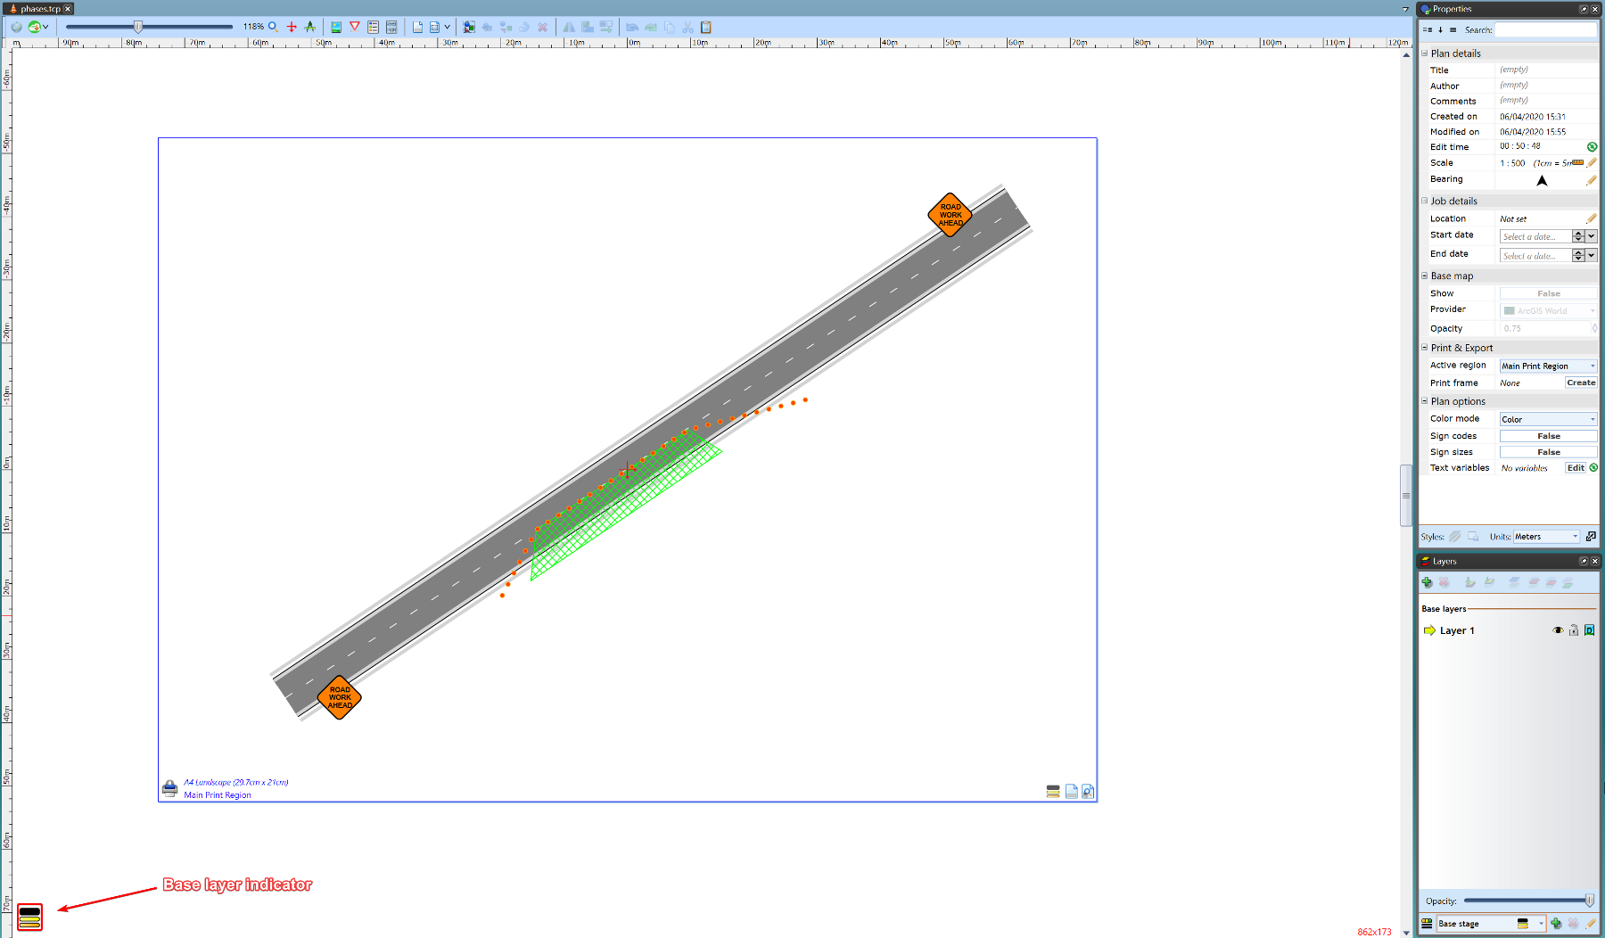

The_Base_Layer

The following images show the two stages (daytime and nighttime)

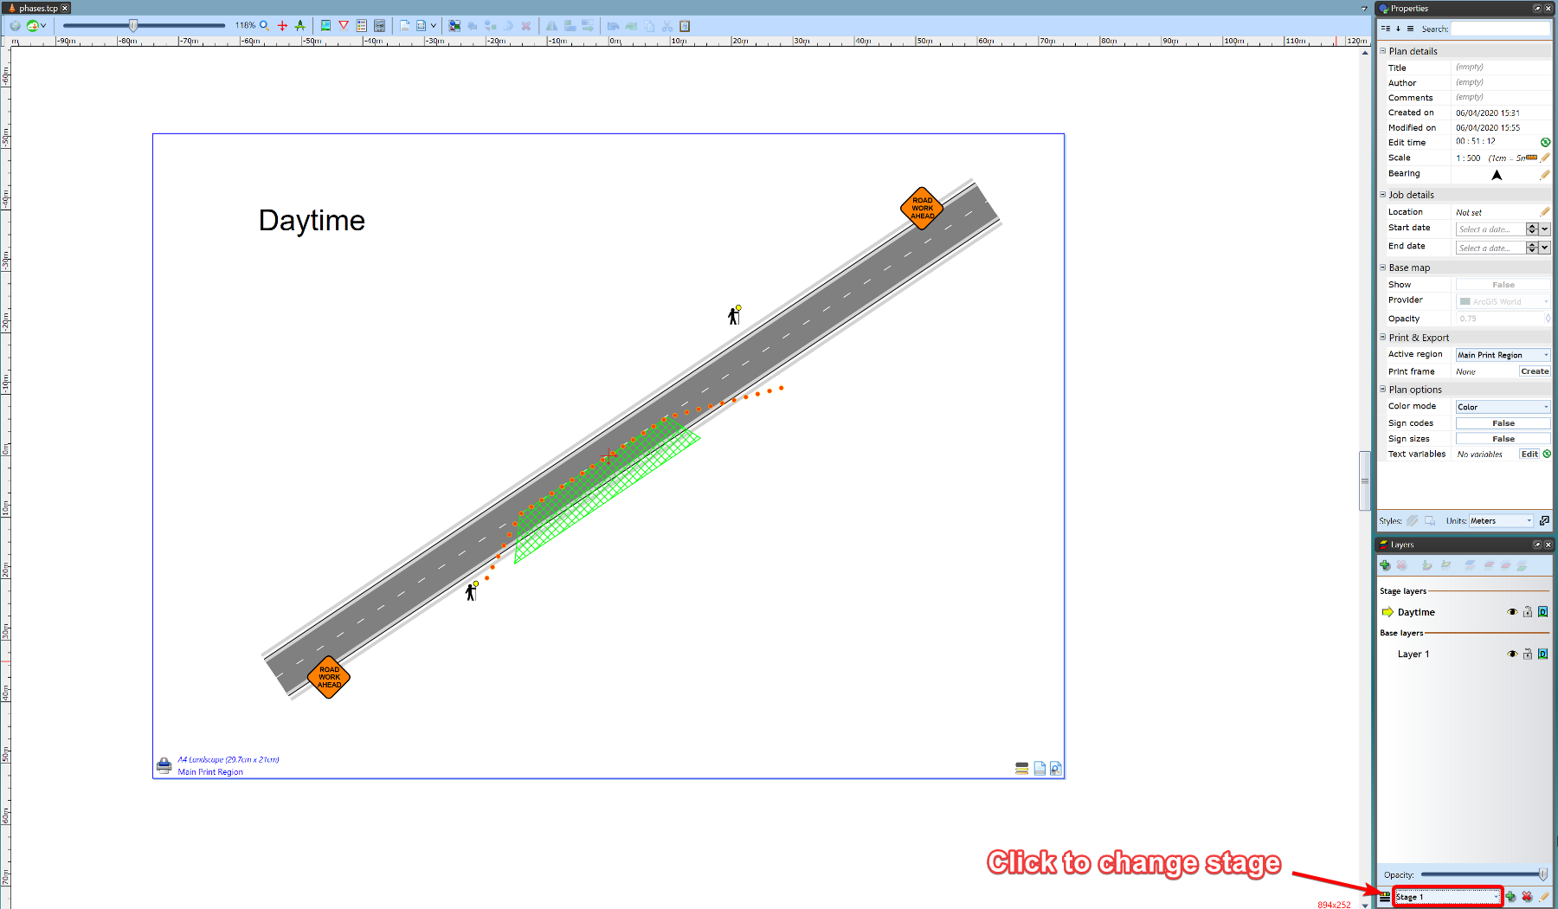

Day_Time_Stage

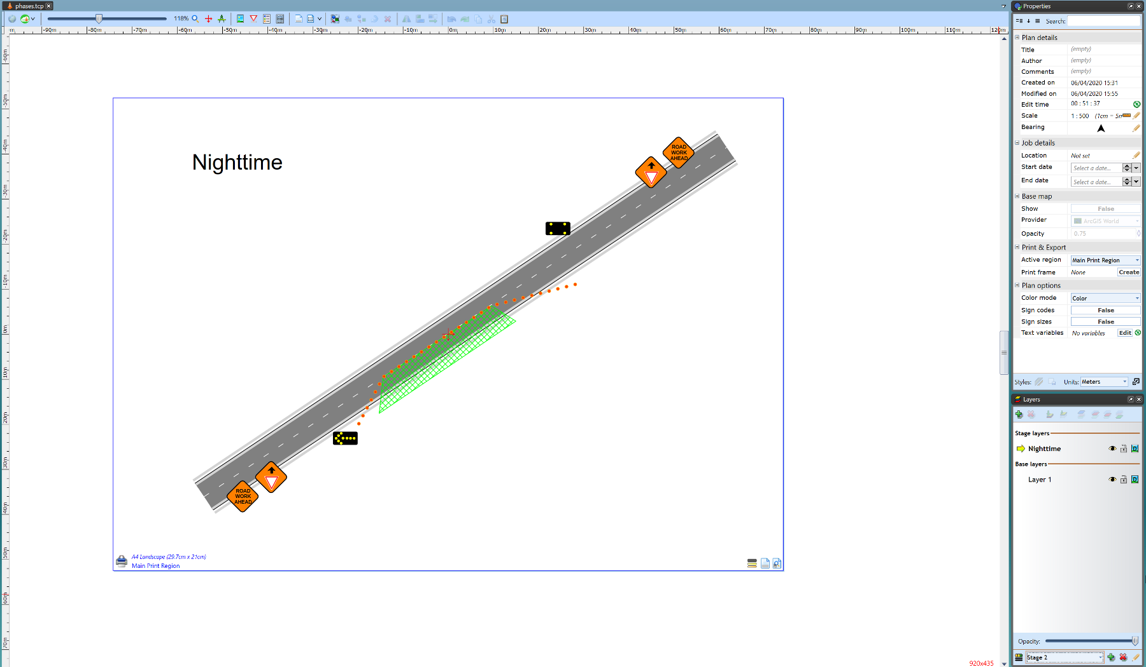

Night_Time_Stage